**Assignment-1**

**Data Warehousing**

J.Rakshitha Devi

**INTRODUCTION:**

In today's data-driven business environment, the capacity to efficiently gather, store, and evaluate information has emerged as a crucial competitive advantage. Businesses that are able to leverage their data are better able to stay ahead of the curve, spur innovation, and make well-informed decisions. The idea of data warehousing lies at the core of this data-driven revolution. Organizations may unlock the value of their many data sources and turn them into actionable insights by utilizing data warehousing as the cornerstone for their data-driven strategy.

Data warehouses enable companies to improve their overall competitiveness, optimize their operations, and make better decisions by offering a consolidated, integrated, and high-performance data repository. The concept of data warehousing, the many kinds of data warehouses, the data warehousing process, typical use cases, and the essential elements of a strong data warehousing system will all be covered in this extensive article.

**DATA WAREHOUSING:**

Data Warehousing refers to the process of collecting, storing, managing, and analyzing large volumes of data from various sources in a central repository known as a data warehouse. This centralized system is designed to support business intelligence (BI), data analytics, and decision-making processes.

The concept was first introduced in the 1980s to help organizations store historical data and enable analytical querying. Unlike traditional operational databases, data warehouses are optimized for read-heavy queries and complex data analysis rather than real-time transactional processing.

A **Data Warehouse** typically exhibits the following characteristics:

* **Subject-Oriented**: Organized around key business areas such as sales, finance, and marketing.
* **Integrated**: Consolidates data from multiple heterogeneous sources into a consistent format.
* **Time-Variant**: Stores historical data to allow for trend analysis and forecasting.
* **Non-Volatile**: Once data is entered, it is not changed or deleted, only appended

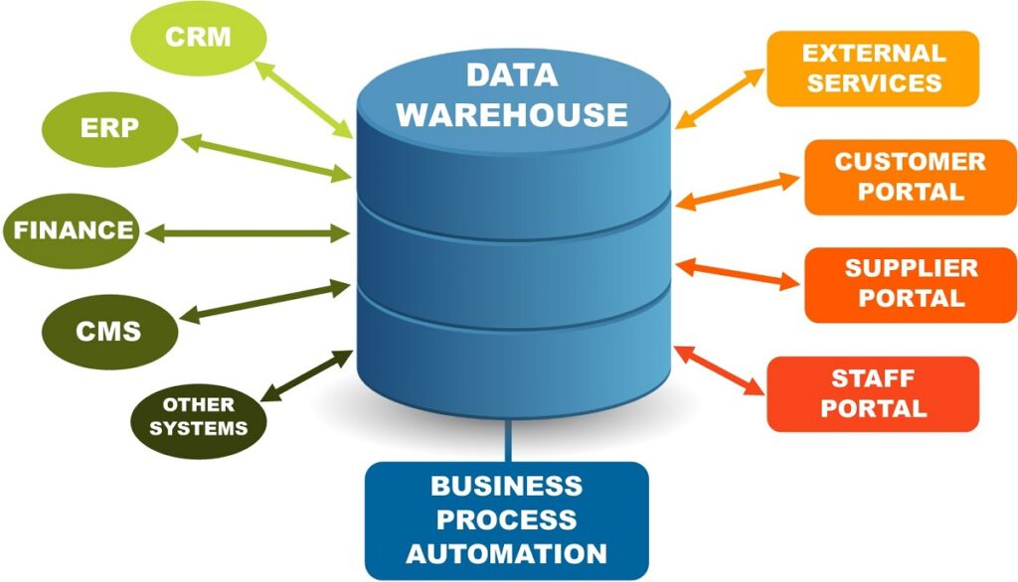

## 

# 

# **Data Warehouse Architecture**

## Data Warehouse Architecture defines the overall design and structure used to build, manage, and operate a data warehouse. It outlines how data flows from various sources into the warehouse and how it is processed, stored, and accessed for business intelligence and analytics.A well-designed architecture ensures scalability, data integrity, performance, and security.A data warehouse is a system that helps businesses make better decisions by combining data from various sources and organizing it under a unified architecture. It streamlines data management, reporting, and storage, increasing the effectiveness of analysis. Data warehouse architecture efficiently manages and stores data by using a structured framework.

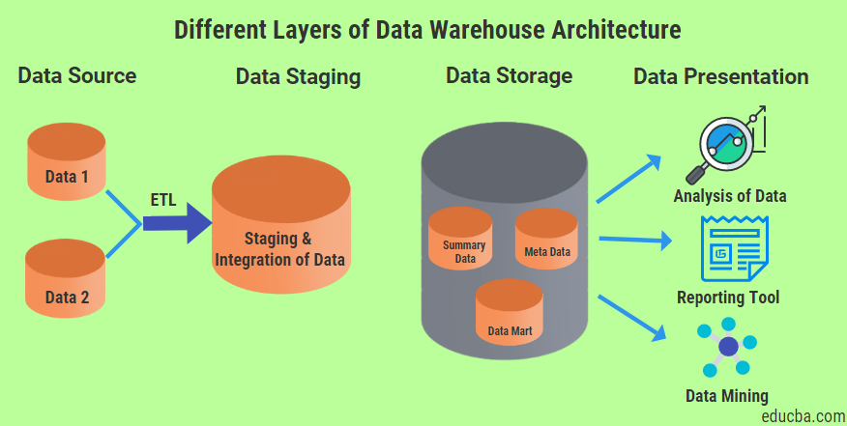

## 

## 

## 

## 

## **Types of Data Warehousing**

## Different types of data warehousing structures exist to meet diverse organizational needs:

**1. Enterprise Data Warehouse (EDW):** An EDW is a centralized data warehouse that serves the entire organization, providing a single source of truth for all business data. EDWs are typically large-scale, complex, and designed to support a wide range of analytical and reporting needs.

**2. Departmental Data Warehouse:** A departmental data warehouse is a smaller-scale data warehouse that focuses on the specific needs of a particular department or business unit, such as sales, marketing, or finance.

**3. Data Mart:** A data mart is a subset of a larger data warehouse, typically designed to serve the needs of a specific department or business function. Data marts are often more specialized and targeted than enterprise-wide data warehouses.

**4. Online Analytical Processing (OLAP) Data Warehouse:** OLAP data warehouses are designed to support complex, multi-dimensional analysis and reporting, allowing users to quickly and easily explore data from multiple perspectives.

**4. Real-Time Data Warehouse:** Real-time data warehouses are designed to provide near-instantaneous access to the latest data, enabling organizations to make decisions based on the most up-to-date information.

## 

## 

## 

## 

## **Data Warehousing Process**

The data warehousing process involves multiple steps designed to ensure accurate, consistent, and timely data delivery to end users.

**1.Data Extraction:** The first step in the data warehousing process is to extract data from various source systems, such as operational databases, ERP systems, and external data sources.

**2. Data Transformation:** Once the data has been extracted, it must be transformed into a consistent format that can be easily integrated into the data warehouse. This may involve cleaning, standardizing, and enriching the data.

**3. Data Loading:** The transformed data is then loaded into the data warehouse, where it is stored in a structured and organized manner, typically using a star schema or snowflake schema design.

**4. Data Modeling:** The data in the data warehouse is modeled to support the specific analytical and reporting needs of the organization. This may involve creating fact tables, dimension tables, and other data structures.

**5. Data Maintenance:** Ongoing maintenance of the data warehouse is essential to ensure that the data remains accurate, up-to-date, and aligned with the organization’s evolving needs. This may include tasks such as data backup, disaster recovery, and data archiving.

**Use Cases for Data Warehousing**

Data warehousing has a wide range of applications across various industries and business functions. Some of the most common use cases include:

**1. Business Intelligence and Reporting:** Data warehouses provide a centralized repository of data that can be used to generate reports, dashboards, and other business intelligence tools, enabling organizations to make more informed decisions.

**2. Sales and Marketing Analytics:** Data warehouses can be used to analyze sales data, customer behavior, and digital marketing campaigns, helping organizations identify trends, optimize their marketing strategies, and improve customer engagement.

**3. Financial Analysis:** Data warehouses can be used to track financial data, such as revenue, expenses, and profitability, allowing organizations to identify areas for cost savings, improve financial planning, and ensure compliance with regulatory requirements.

**Conclusion**

A data warehouse is a centralized system designed to store, integrate, and manage large volumes of structured data from multiple sources for analysis and decision-making. It supports business intelligence by providing historical, consistent, and accurate data for reporting and analytics. With advancements in cloud computing, modern data warehouses offer better scalability, speed, and flexibility, making them essential tools for organizations to gain insights, improve performance, and drive strategic decisions.